http://mandypc:8399/201504layer/
http://mandypc:8099/arcgismanager/main/main.jsf （ arcgismanager / gisserver ）

http://proceedings.esri.com/library/userconf/feduc08/papers/techworkshops/feduc2008_arcgisserver_webadf.pdf

看视频和资料
Gis plugin

C:\Program Files (x86)\ArcGIS\java\tools\eclipse_plugin\arcgis_update_site\engine
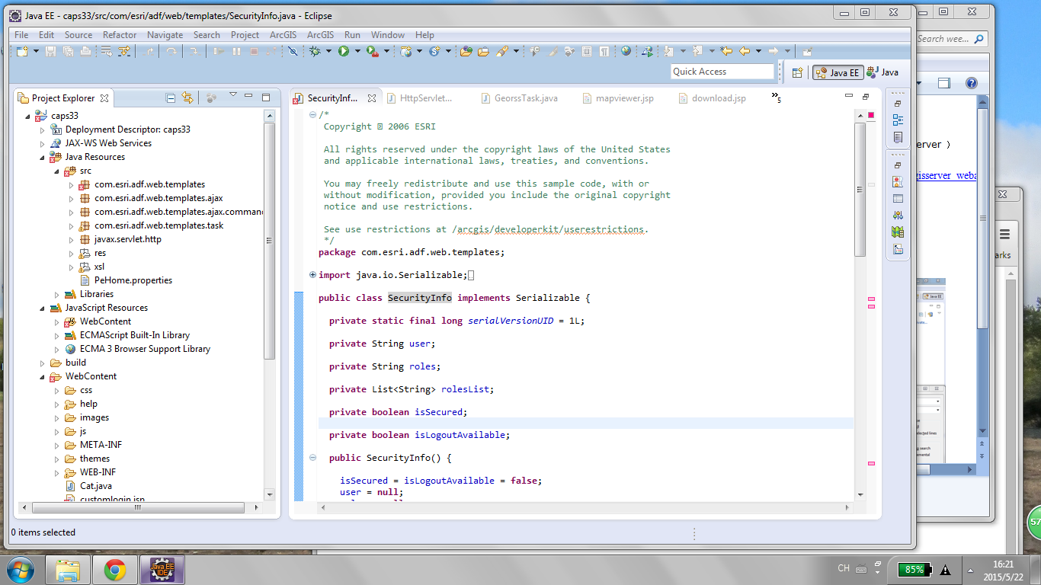

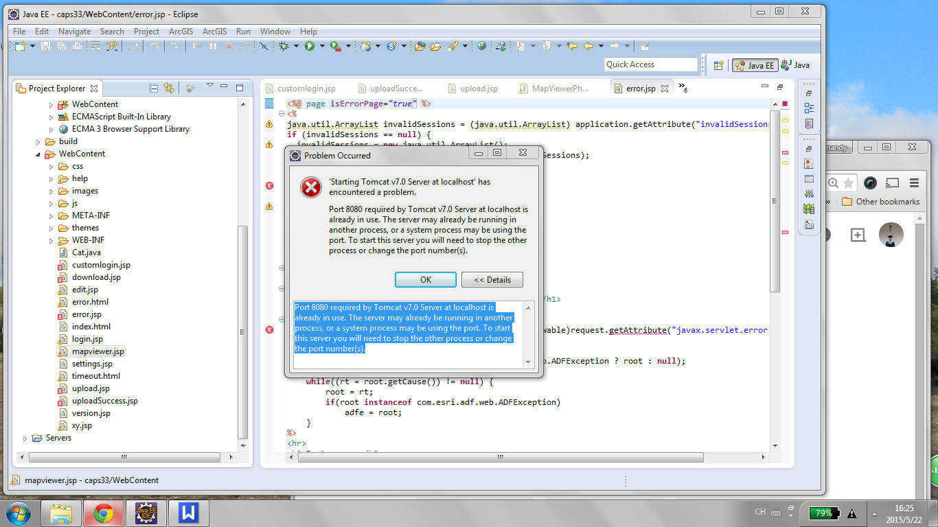

Port 8080 required by Tomcat v7.0 Server at localhost is already in use. The server may already be running in another process, or a system process may be using the port. To start this server you will need to stop the other process or change the port number(s).

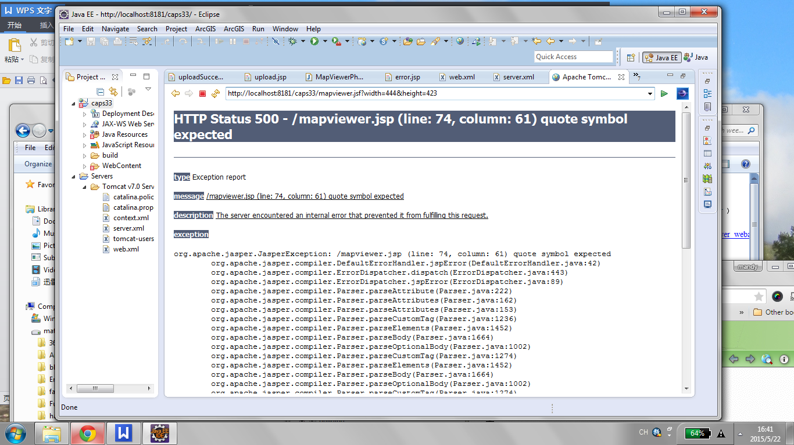

The method invalidate() is undefined for the type Object

Multiple annotations found at this line:
- The method getParameter(String) is undefined for the type
HttpServletRequest
- The method getParameter(String) is undefined for the type
HttpServletRequest

Multiple annotations found at this line:
- The method getId() is undefined for the
type Object
- The method getId() is undefined for the
type Object

https://www.youtube.com/watch?v=Wcj0QtC-xks
http://resources.esri.com/help/9.3/arcgisserver/adf/java/help/doc/5257ae83-0b1e-4dbb-a120-8a4c79d14d50.htm

